[NTSCE-14699](https://onejira.verizon.com/browse/NTSCE-14699)  
Env-SIT   
Instance-uat7  
Project ID-17084141  
POR Status Component-  
  
TC_01 Verify POR Status selection and field updates with valid budget code , In-Building privilege and In-Building site type - POR selection  
  
1)fields update:  
-release to build task:  
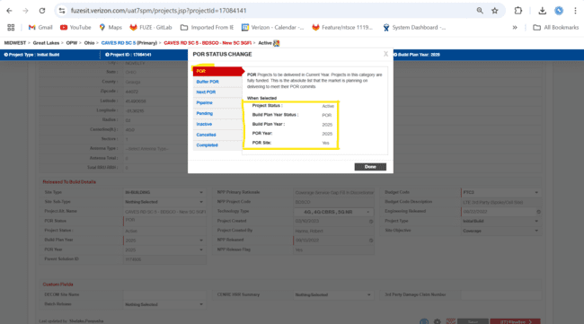  
  
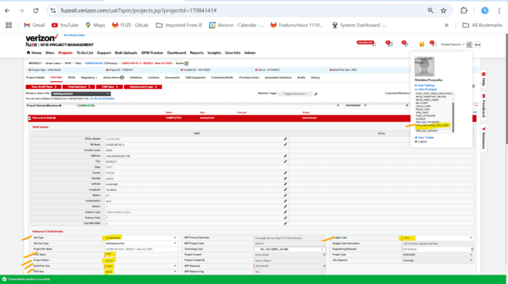  
-Project Detail Page:

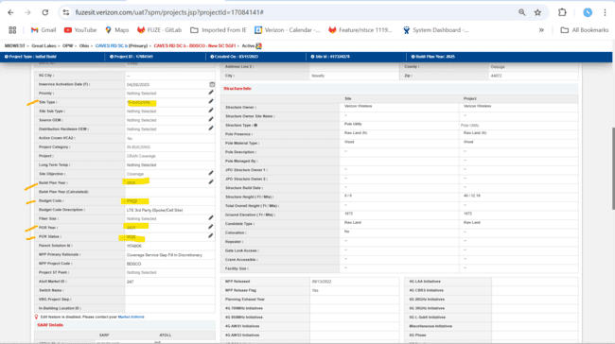  
transport milestone-  
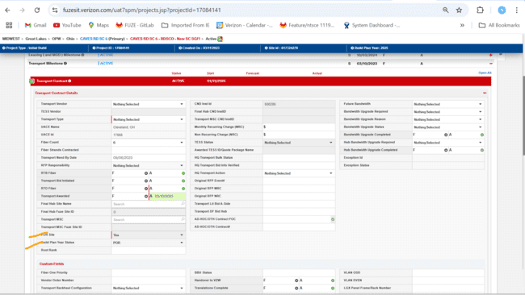  
TC_02 Verify POR Status selection and field updates with invalid budget code , In-Building privilege and In-Building site type - POR selection  
Realease to build task-  
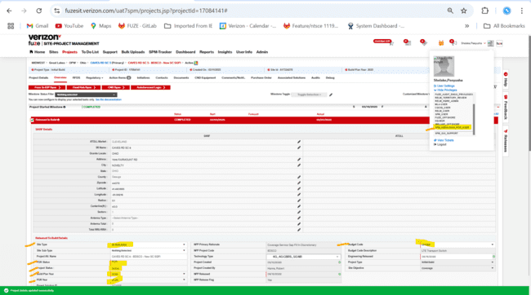  
Project detail Page-  
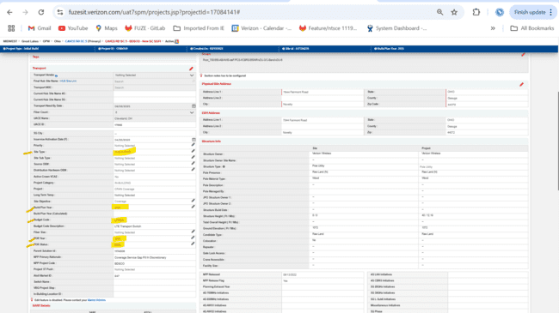  
Transport Milestone-  
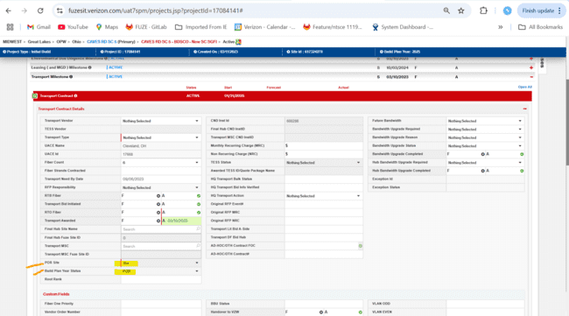  
TC_03 Verify POR Status selection and field updates with invalid budget code , In-Building privilege and No In-Building site type - POR selection  
project id- 2010978  
field update:  
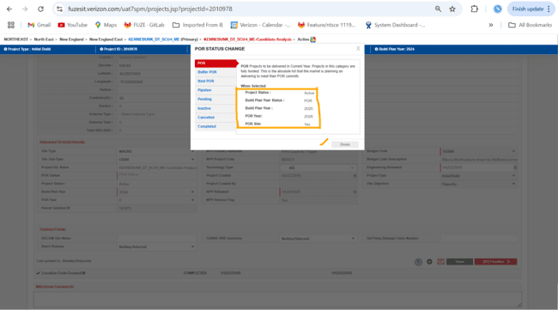  
Release To Build Task-  
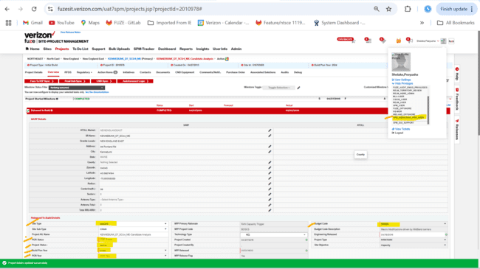  
  
Project Details Page-  
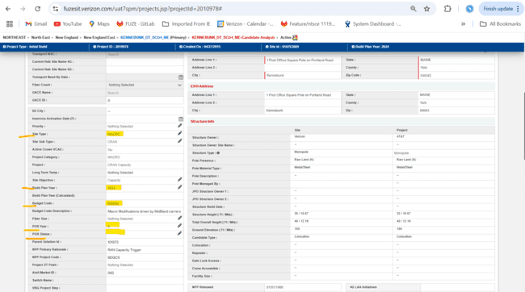  
  
  
  
TC_04 Verify POR Status selection and field updates with invalid budget code ,no In-Building privilege and In-Building site type - POR selection  
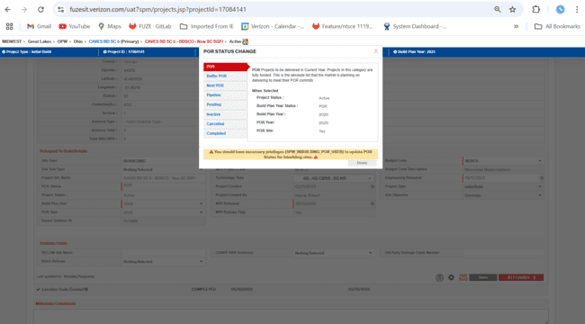  
budget code save successfully-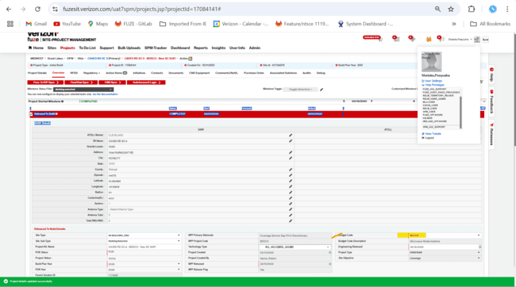  
  
  
TC_05 Verify POR Status selection and field updates with valid budget code ,In-Building privilege and In-Building site type - Buffer POR selection  
1)fields update:  
-release to build task:  
  
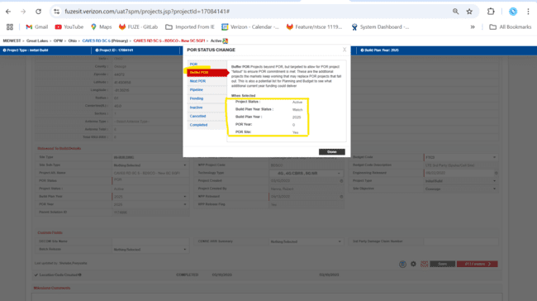  
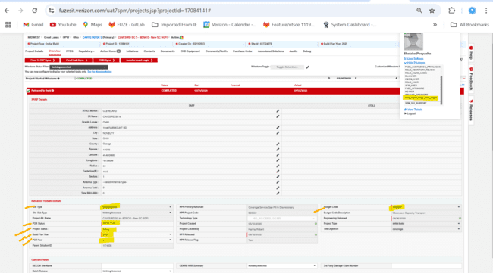  
-Project Details Page  
  
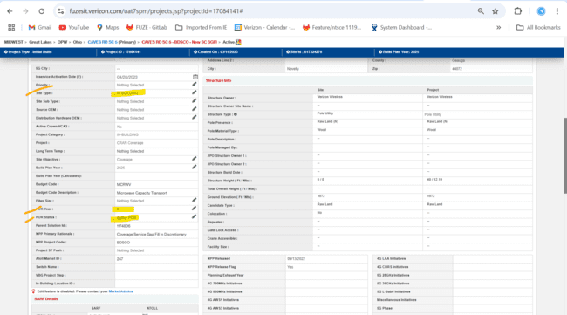  
-Transport Detail Page  
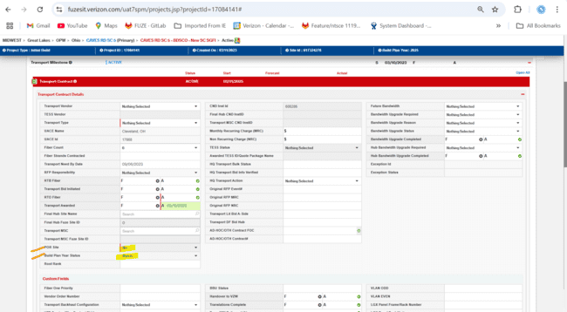  
TC_06 Verify POR Status selection and field updates with invalid budget code , In-Building privilege and In-Building site type – Buffer POR selection  
Release to build task-  
  
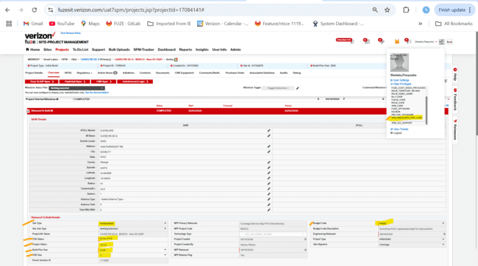  
Project details page-  
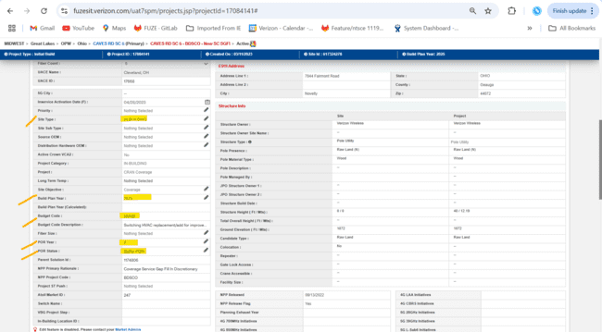  
Transport Milestone-  
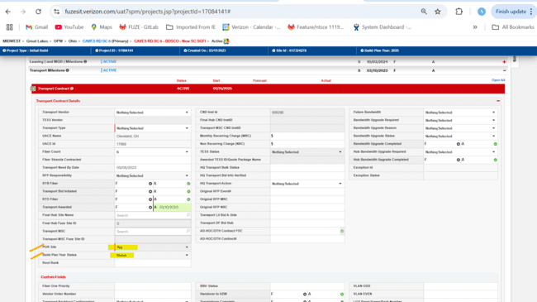  
TC_07 Verify POR Status selection and field updates with invalid budget code , In-Building privilege and No In-Building site type – Buffer POR selection  
project id- 2010978  
field update:  
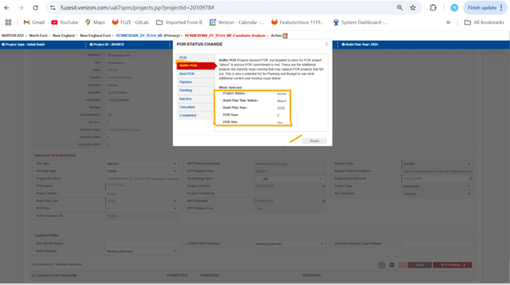  
Release to build task-  
  
Project Detail Page-  
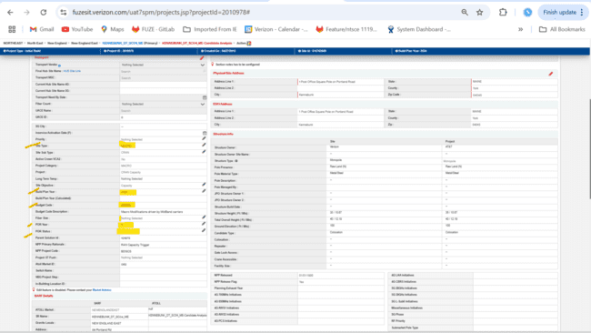  
  
  
TC_08 Verify POR Status selection and field updates with invalid budget code and no In-Building privilege - Buffer POR selection  
  
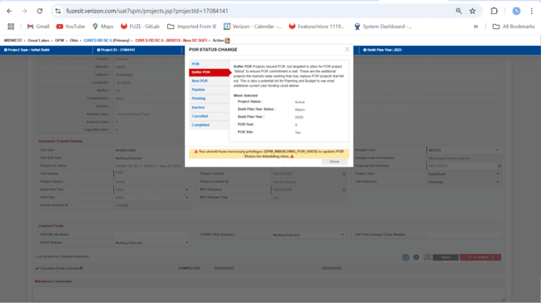  
  
TC_09 Verify POR Status selection and field updates with valid budget code, In-Building Privileges and In-Building site type- Next POR selection  
-release to build task:  
  
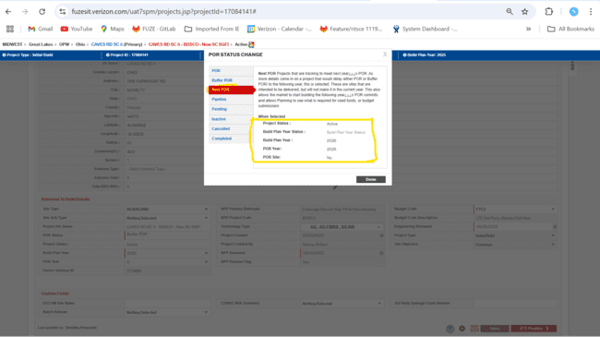  
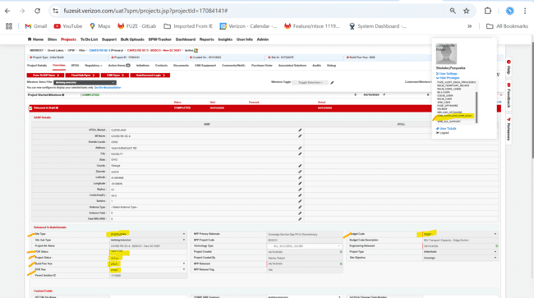  
-Project Details page:  
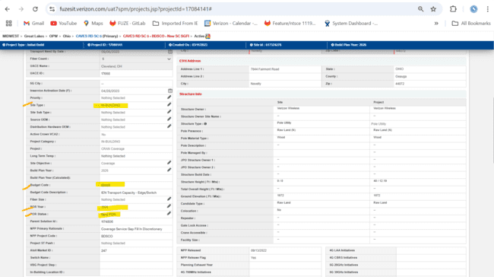  
-Transport Milestone:  
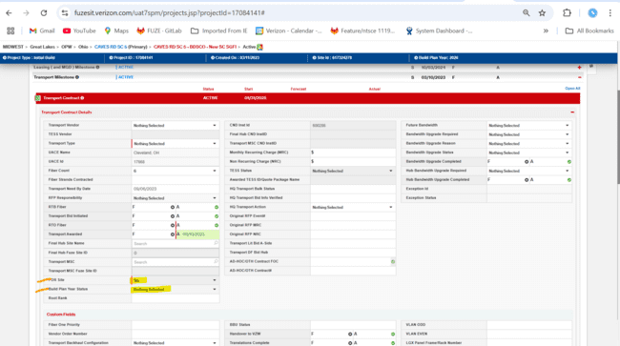  
TC_10 Verify POR Status selection and field updates with Invalid budget code, In-Building Privileges and In-Building site type- Next POR selection  
Release to build task-  
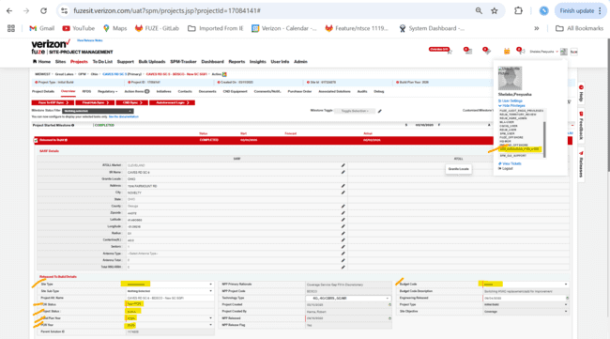  
Project Details page-  
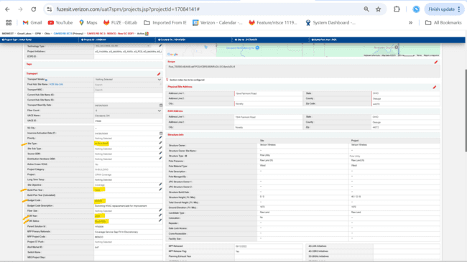  
Transport Milestone-  
TC_11 Verify POR Status selection and field updates with invalid budget code , In-Building privilege and No In-Building site type – Next POR selection  
project id- 2010978  
field update:  
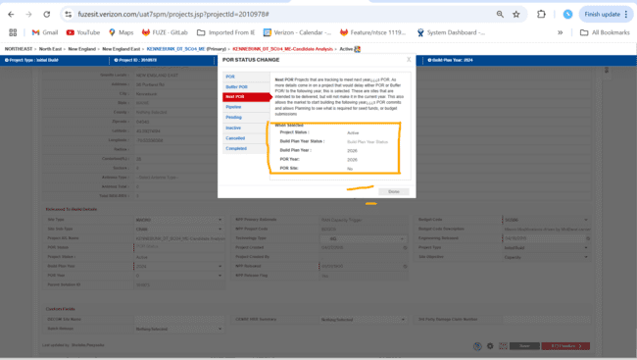  
Release to Build-  
  
Project Detail Page-  
  
  
  
TC_12 Verify POR Status selection and field updates with invalid budget code , No In-Building privilege and In-Building site type – Next POR selection  
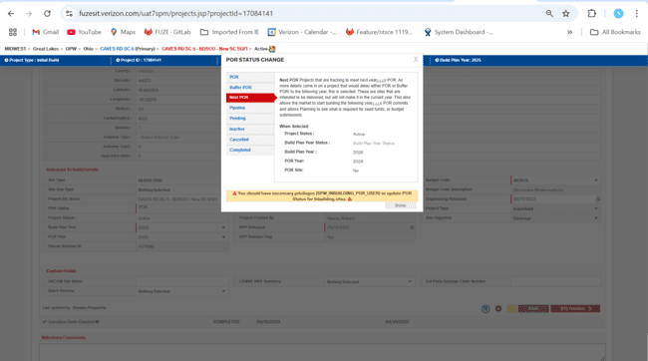  
  
  
TC_13 Verify POR Status selection and field updates with valid budget code, in-Building Privileges and In-Building site - Pipeline selection  
-Release to Build task:  
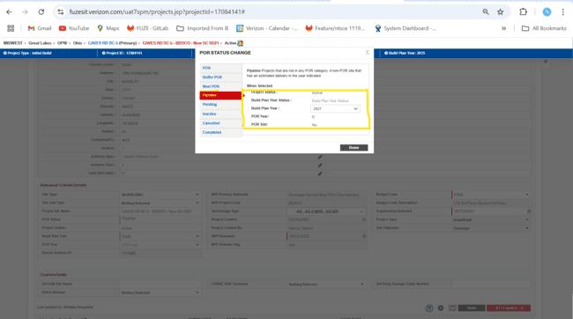  
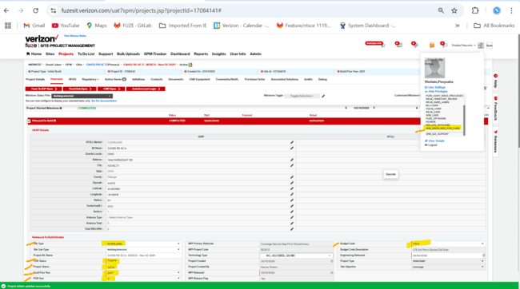  
  
-Project Details Page:  
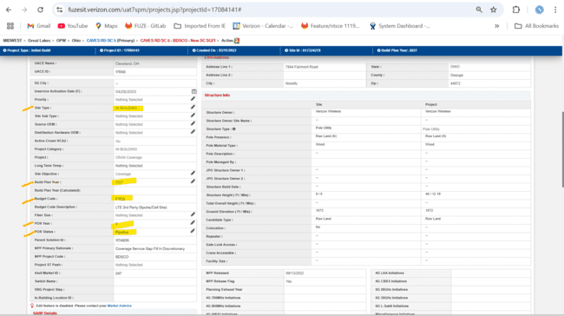  
  
-Transport Milestone:  
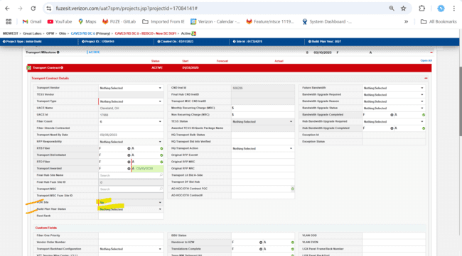  
TC_14 Verify POR Status selection and field updates with Invalid budget code, in-Building Privileges and In-Building site - Pipeline selection   
Release to Build task:  
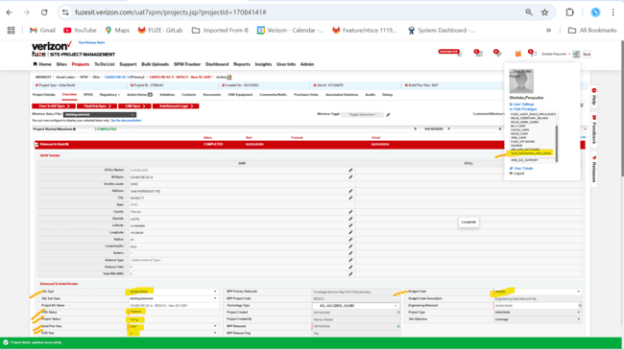  
Project Details Page-  
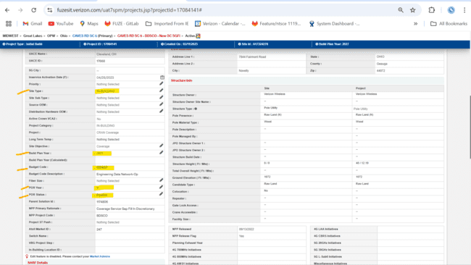  
Transport Milestone-  
  
  
TC_15 Verify POR Status selection and field updates with Invalid budget code, in-Building Privileges and No In-Building site type- Pipeline selection   
project id- 2010978  
field Update:  
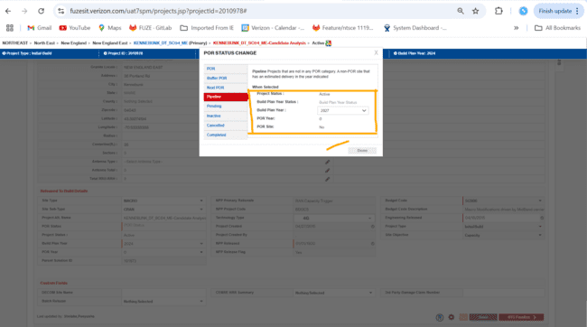  
Release to Build task:  
  
Project Details Page-  
  
  
  
  
TC_16 Verify POR Status selection and field updates with Invalid budget code , No in-Building Privileges and In-Building site type- Pipeline selection   
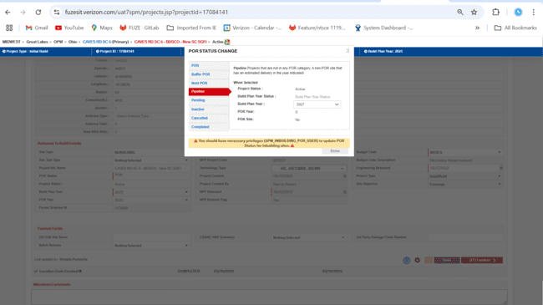  
  
  
TC_17 Verify POR Status selection and field updates with valid budget code , in-Building Privileges and In-Building site type- Pending selection  
-Release to Build:

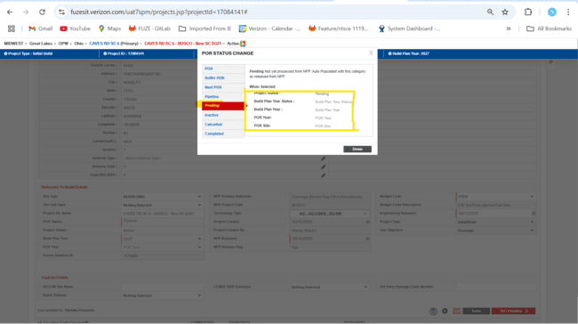  
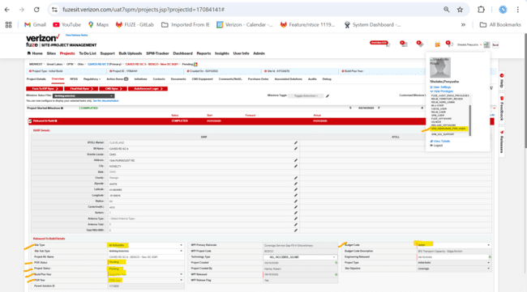  
-Project Details Page:  
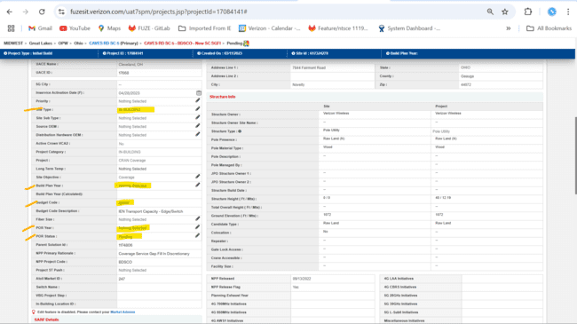  
-transport milestone:  
TC_18 Verify POR Status selection and field updates with Invalid budget code, in-Building Privileges and In-Building site - Pending selection   
Release to Build task:  
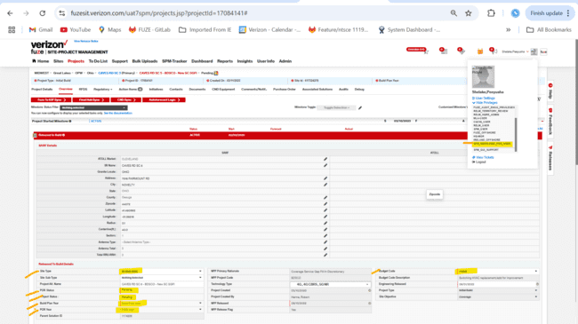  
Project Details Page-  
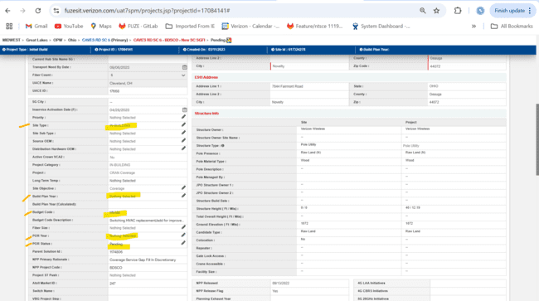  
Transport Milestone-  
TC_19 Verify POR Status selection and field updates with Invalid budget code, in-Building Privileges and No In-Building site - Pending selection   
Release to Build task:  
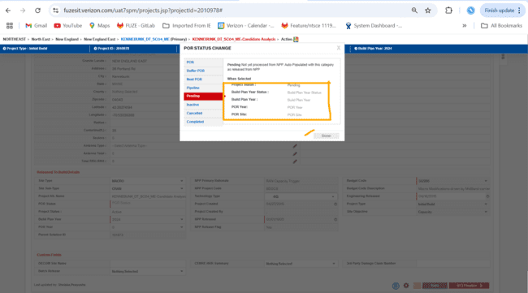  
Release to build task-  
  
Project Details Page-  
  
  
  
TC_20 Verify POR Status selection and field updates with Invalid budget code , No in-Building Privileges and In-Building site type- Pending selection  
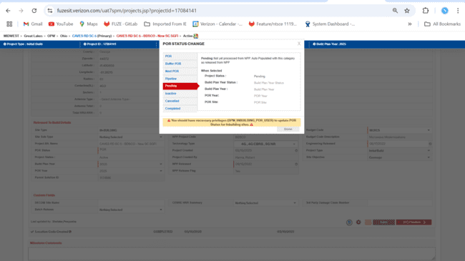  


TC_21 Verify POR Status selection and field updates with valid budget code, In-Building privileges and In-Building Site type - Inactive selection   
Release to Build Task:  
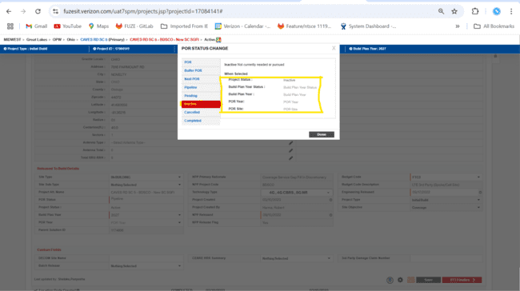  
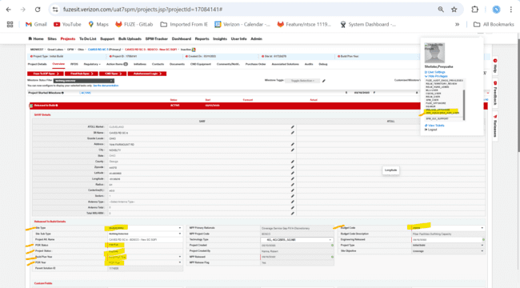  
-Project Details Page:  
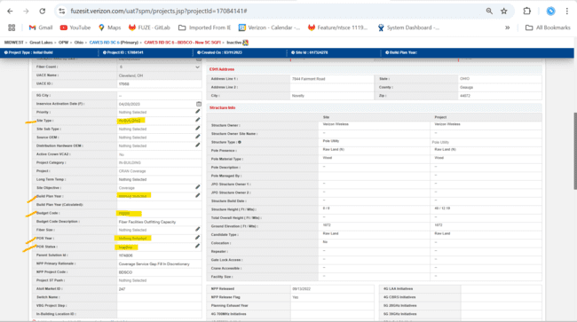  
Transport Milestone:  
TC_22 Verify POR Status selection and field updates with Invalid budget code, in-Building Privileges and In-Building site - Inactive selection  
Release to Build Task-  
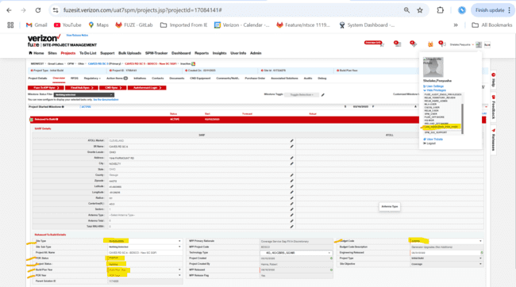  
Project Details Page-  
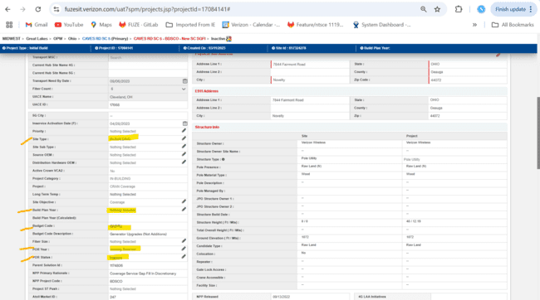  
Transport Milestone-  
TC_23 Verify POR Status selection and field updates with Invalid budget code, in-Building Privileges and No In-Building site - Inactive selection  
Field Update-  
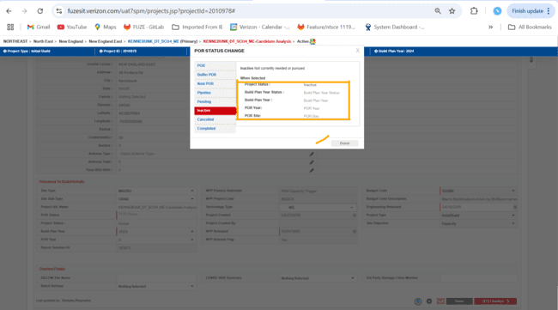  
Release to Build Task-  
  
Project Details Page-  
  
  
TC_24 Verify POR Status selection and field updates with Invalid budget code , No in-Building Privileges and In-Building site type- Inactive selection  
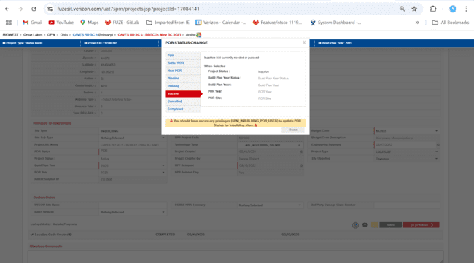  


TC_25 Verify POR Status selection and field updates with valid budget code ,In-Building Privileges and In-Building Site type - Cancelled selection  
Release to build task-  
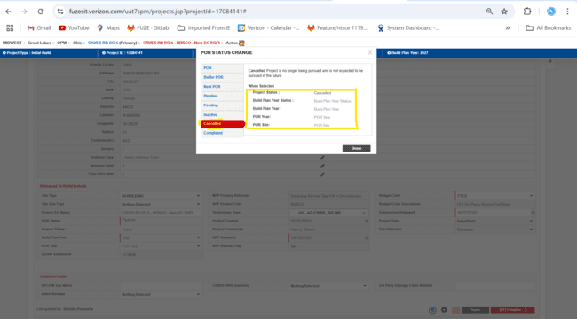  
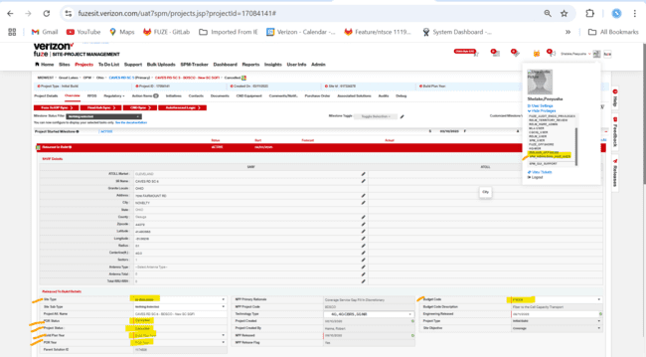  
Project Details Page:  
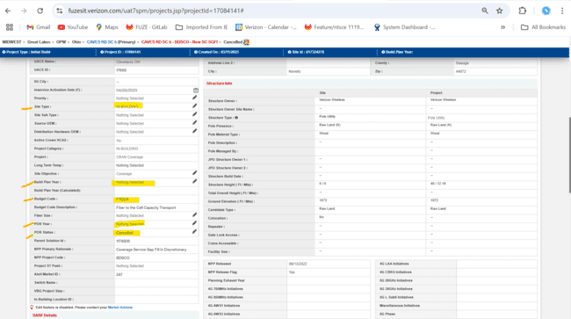  
TC_26 Verify POR Status selection and field updates with Invalid budget code, in-Building Privileges and In-Building site - cancelled selection  
Release to Build Task-  
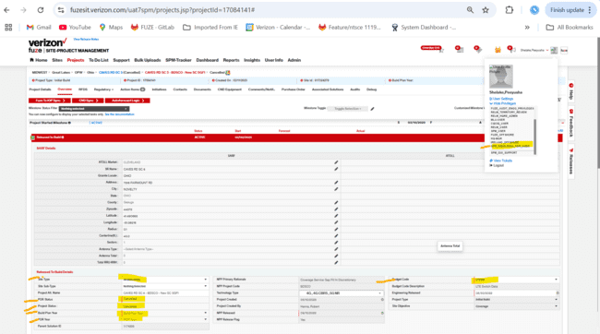  
Project Details Page-  
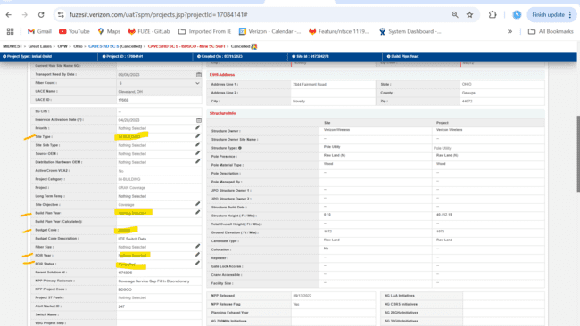  
Transport Milestone-  
TC_27 Verify POR Status selection and field updates with Invalid budget code, in-Building Privileges and No In-Building site - cancelled selection  
project id- 2010978  
Field Update:  
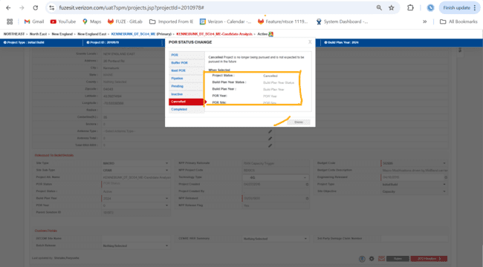

Release to Build Task-  
  
Project Details Page-  
  
TC_28 Verify POR Status selection and field updates with Invalid budget code, No in-Building Privileges and In-Building site type- Cancelled selection  
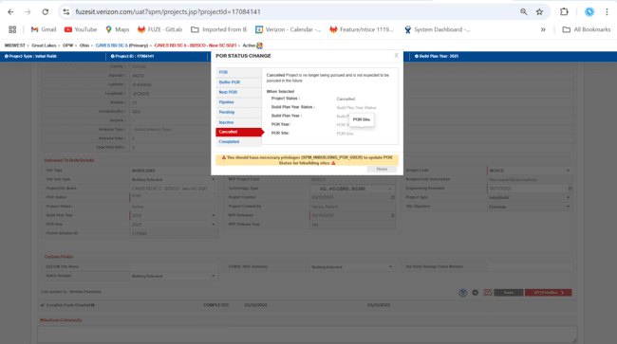  


* TC_29 Verify POR Status selection and field updates with valid budget code, In-Building Privileges ,In-Building Site Type - Completed selection between 1/1 and 2/15  
  field updates:  
  Release to build task-  
  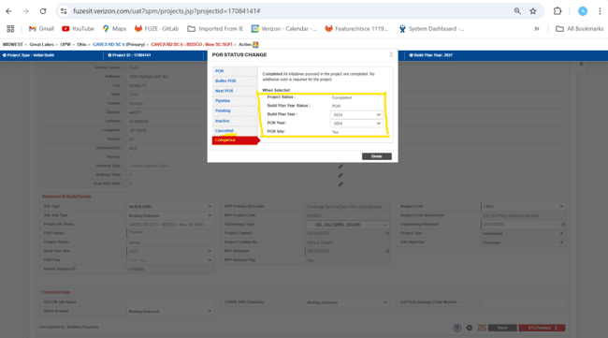  
  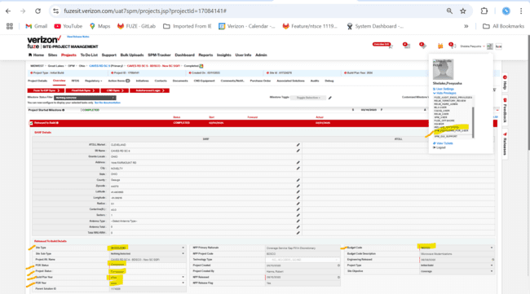  
  project details page-  
  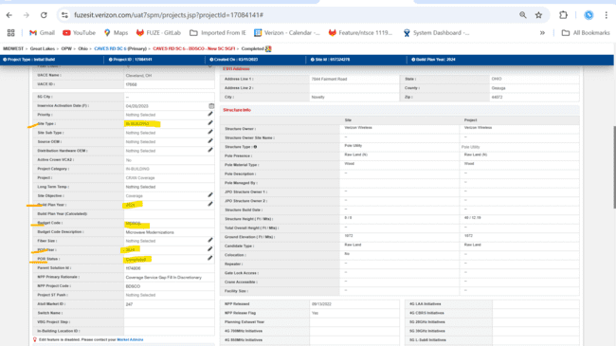  
  TC_30 Verify POR Status selection and field updates with Invalid budget code, in-Building Privileges and In-Building site - Completed selection  
  Release to Build Task-  
  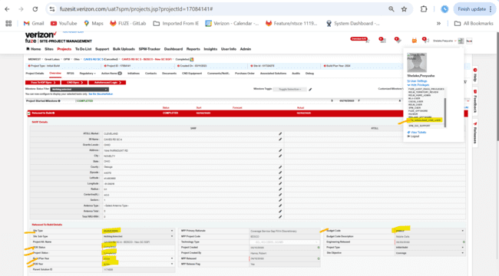  
  Project Details Page-  
  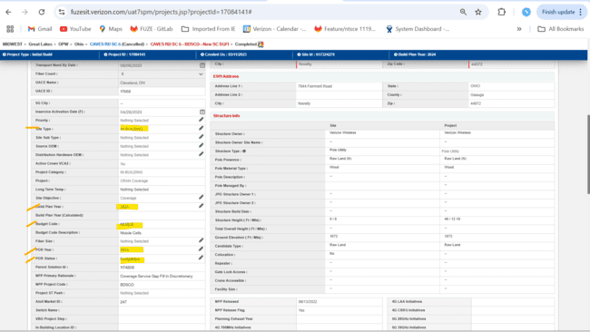  
  Transport Milestone-  
    
  TC_31 Verify POR Status selection and field updates with Invalid budget code, in-Building Privileges and No In-Building site - Completed selection  
  project id- 2010978  
  Field Update-  
  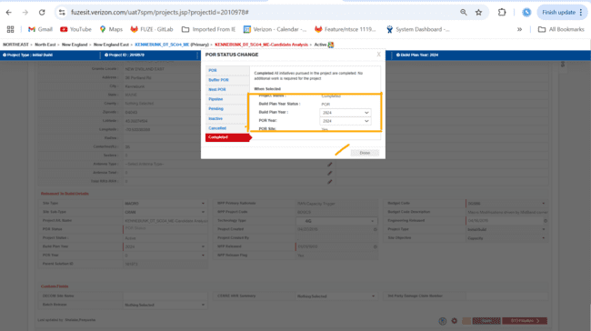  
  Release to Build Task-  
    
  Project Detail Page-  
    
    
  TC_32 Verify POR Status selection and field updates with Invalid budget code , No in-Building Privileges and In-Building site type- Completed selection  
  